Chapter 3, Problem 49.

Find v_{o} and i_{o} in the circuit of Fig. 3.94.

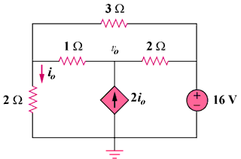

27 V

Figure 3.94
For Prob. 3.49.

